EDUBRIDGE LEARNING PVT .LTD

PROJECT DOCUMENTATION

ON

STUDENT MANAGEMENT SYSTEM

CONTENTS

1.ABSTRACT

2.INTRODUTION

3.TYPES OF OPERATIONS

4.FUNCTIONS DESCRIPTION

5.CONCLUSION

6.CODE OUTPUT

Presented by :

Pallavi Suresh Narwade

1. ABSTRACT

Student Management System provides a simple interface for maintenance of student information .It can be used by educational institutes or colleges to maintain the records of students easily.

2.INTRODUCTION

In Introduction part we are explaining about operations and functions also created a reference to the class in the methods like student id, first name, last name, grade levels ,courses, tuition fee ,balance payment etc.,

By using this reference we can call the methods from main method. Used do while-loop and for loop

.Learner will be learning how to add new students to the database.

.The user should be prompted to enter the name and year for each student.

.The student should have a 5-digit unique ID, with the first number being their grade level.

.A student can enroll in the following courses:

History 101

Mathematics 101

English 101

Chemistry 101

Computer Science 101

.Each course costs $600 to enroll.

.The student should be able to view their balance and pay the tuition.

.To see the status of the student ,we should see their name ,ID ,courses ,enrolled and balance.

Flow chart:

1.Student Name 1.Unique ID 1.Courses

2.Student year 2.First number 2.Course costs

1.Balance

2.Pay the tuition.

3.TYPE OF OPERATIONS

1.Class name is created with StudentDatabaseApp.java and other class with Student.java.

2.Import java.util.Scanner used to obtaining input of the primitive types like int, double etc. and strings.it is easiest way to read input in a java program.

3.This() constructor call can be used to invoke the current class constructor.it is used to reuse the constructor.

4.do-while loop is an expression which is tested. If the condition is true, the loop body is executed and control goes to update expression. As soon as the condition becomes false, loop breaks automatically.

4.FUNCTIONS DESCRIPTION

1.Variables:

|  |  |  |  |  |
| --- | --- | --- | --- | --- |
| S.no | Variables | Description | Data Type Size | Size |
| 1 | ID | Enroll ID | Int | 4 |
| 2 | Name | Student Name | String | - |
| 3 | Class Level | 01-04. | Int | 4 |
| 4 | Course | Student Course | String | - |
| 5 | Balance | Student Balance | String | - |
| 6 | Payments | Student Payments | String | - |

Do-while loop is an expression which is tested. If the condition is true, the loop body is executed and control goes to update expression. As soon as the condition becomes false, loop breaks automatically.

Example:do{

//code to be executed/loop body

//update statement

}while(condition);

”for loop” in java is an entry controlled loop that facilitates a user to execute a block statement iteratively for fixed number of times.

Example: for(int i=0;i<5;i++){

System. out. Print ln ( i );

}

5.CONCLUSION

Also we have used the Core Java that is JAVA8

6.Code Output

When ID is correct -

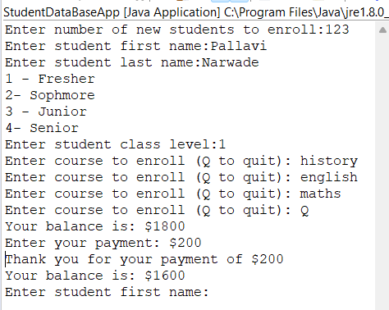

When ID is Wrong-

